SECOND NOTICE OF DEVELOPMENT VARIANCE PERMIT RESOLUTION

Notice is hereby given that the Council of the City of Nanaimo, at its meeting to be held on 2014-SEP-29, at 7:00 p.m. in the Shaw Auditorium, Vancouver Island Conference Centre, 80 Commercial Street, Nanaimo, B.C., will consider the adoption of a resolution to issue a development variance permit as follows:

Development Variance Permit No. DVP00217

Variance
A development variance permit application was received from STANTEC ARCHITECTURE LTD. (Mr. Doug Hamming), on behalf of the BRITISH COLUMBIA TRANSPORTATION FINANCING AUTHORITY, to vary the provisions of the City of Nanaimo “SIGN BYLAW 1987 NO. 2850” in order to permit three LED animated signs at the Departure Bay Ferry Terminal.

Bylaw Regulations
Section 3 (22) of the City of Nanaimo “SIGN BYLAW 1987 NO. 2850” prohibits “a sign which is animated or includes automated changeable copy except where approved through a development variance permit”. Section 5 (5) (A) (iii) (a) of the Sign Bylaw limits the maximum allowable sign area for a freestanding sign within the Waterfront Zones to 10m².

A variance is required to permit 3 automated changeable copy (LED) signs of 20.21m² each on the subject property. NOTE- this is an amended variance of the applicant’s original request (see back page for explanation of changes).

Location
The subject property is located at 680 TRANS CANADA HWY. This property is legally described as Block H, Plan VIP75206, District Lot 227, Section B1, Block A, District Lot 227 & 442 VIP75207; Part of Section 1 in red on Plan 1023R except 11762, 1402RW and 42141; Part of Lot 1 in 1402RW of Plan 11762 except VIP69889; Lot A Plan 46150 and Lot 1 Section 1, Nanaimo District, Plan VIP85783 (Licence 112720 for commercial wharf purposes). The subject property is identified on Schedule A.

This application may be reviewed at the Community Safety & Development Division,
411 Dunsmuir Street, Nanaimo, B.C., during normal business hours 8:30 a.m. to 4:30 p.m., Monday to Friday, excluding statutory holidays, from 2014-SEP-18 to
2014-SEP-29, inclusive. Anyone wishing to address this matter will be given the opportunity to be heard at the Council meeting.

This notification is published in accordance with Section 922 of the Local Government Act.

Community Safety & Development
CITY OF NANAIMO
250 755-4429

PLEASE NOTE: This is the second City of Nanaimo NOTICE you may have received regarding this application for LED signs at the Departure Bay Ferry Terminal. An earlier notice was sent regarding the 2013-OCT-7 Council meeting. At this meeting, Council referred the application back to staff for further consultation between BC Ferries and the Brechin Hill Community Association. As part of their consultation process on 2013-OCT-24, BC Ferries hosted an open house on the subject property, regarding the proposed signage. The applicants have since revised their applications based on comments heard during this consultation by:
- reducing the LED sign height for the free standing signs by 5.3m (3.8m without light baffle included);
- reducing the individual LED sign size by 10.9m²;
- reducing the overall sign area by 1.6m²; and
- increasing the number of LED signs from two to three.

An information package regarding the proposed changes may have already been sent to you by the applicant.

The application is set to return to Council on 2014-SEP-29 for Council’s decision.

The proposed signage is shown below:
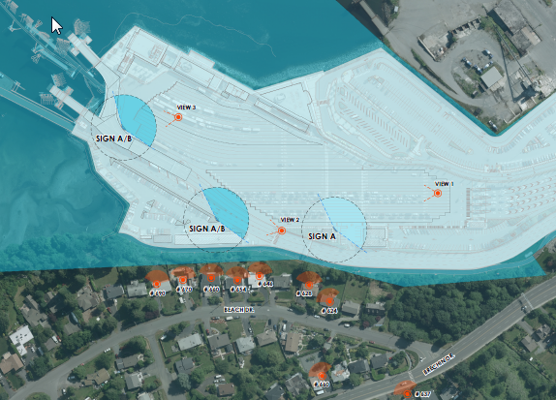
Sign Location Plan
Proposed Free Standing
Sign
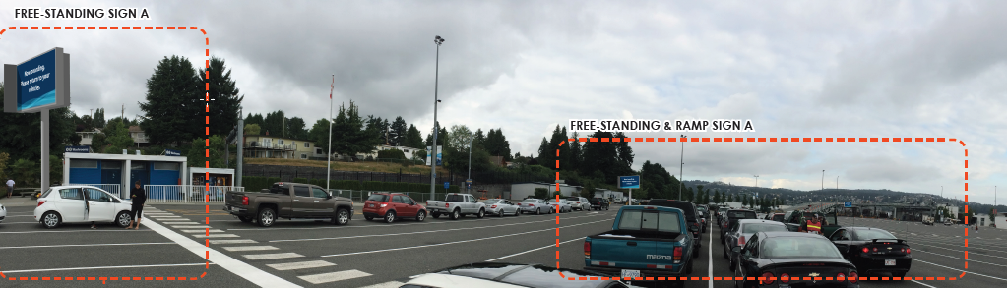
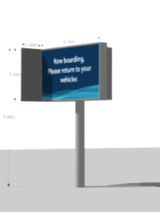
Vehicle Waiting Area View of Proposed Signs
Proposed Cardeck Mounted Sign
Proposed Free Standing Sign
Waiting Area View of Freestanding Signs

